NBSAP 2025–2030 Biodiversity Monitoring Dashboard

System Requirements Specification Document

Prepared for: Rwanda Environment Management Authority (REMA), Ministry of Environment
(MoE), MINECOFIN, Project Reviewers, Auditors, and Stakeholders
Document Reference: NBSAP-COMP-2026-001
Version: 1.0
Date: June 2026
System URL: https://nbsap-dashboard-rw.vercel.app

Document Control
Field | Value
Document  Title | NBSAP 2025–2030 System Analysis, Requirements, Business Process & Architecture  Document
Project | Rwanda NBSAP Biodiversity Monitoring Dashboard
Prepared by | NBSAP Dashboard Development Team
Status | Final
Total Pages | Comprehensive (6 Sections)

TABLE OF CONTENTS

Table of Contents
TABLE OF CONTENTS 2
SECTION 1: EXECUTIVE SUMMARY 3
1.1 Project Overview 3
1.2 System Purpose 4
1.3 Business Objectives 4
1.4 Alignment with Rwanda NBSAP 2025–2030 4
1.5 Key Stakeholders 5
1.6 Expected Benefits 5
1.7 Scope of the System 6
1.8 Major System Capabilities 6
SECTION 2: SYSTEM OVERVIEW 7
2.1 Current System 7
2.2 System Objectives 8
2.3 Core Modules 8
Module 1: Authentication & User Management 8
Module 2: Dashboard & Executive View 8
Module 3: National Targets & Indicators 8
Module 4: Reporting Toolkit (T01–T07) 8
Module 5: Verification Queue 9
Module 6: Interactive Map (GIS) 9
Module 7: RBIS Dashboard 9
Module 8: Reports & Analytics 9
Module 9: Risk & Compliance 9
Module 10: Audit & Governance 9
2.4 User Groups 9
2.5 Reporting Requirements 10
2.6 Monitoring Requirements 10
2.7 Dashboard Requirements 10
2.8 High-Level System Overview Diagram 11
SECTION 3: BUSINESS PROCESS DOCUMENT 12
3.1 Current Process (AS-IS) 12
3.1.1 Pre-System Data Collection Process 12
3.1.2 AS-IS Process Challenges and Bottlenecks 13
3.1.3 AS-IS Process Flow Diagram 14
3.2 Proposed Process (TO-BE) 15
3.2.1 Automated Digital Process 15
3.2.2 Detailed Workflow Diagrams 16
3.3 Approval Flow 19
3.3.1 Complete Approval Flow Diagram 19
SECTION 4: SOFTWARE REQUIREMENTS SPECIFICATION (SRS) 20
4.1 Functional Requirements 20
4.1.1 User Management 20
4.1.2 Dashboard Management 21
4.1.3 Reporting 22
4.1.4 Audit and Compliance 23
4.2 Non-Functional Requirements 24
4.2.1 Performance 24
4.2.2 Security 24
4.2.3 Availability 25
4.2.4 Scalability 25
4.2.5 Usability 25
SECTION 5: USER ROLES AND PERMISSIONS 26
5.1 Role Definitions 26
5.1.1 Administrator — dashboard_management 26
5.1.2 REMA M&E Officer / Lead Ministry Reporter — 26
5.1.3 Sector Reviewer / District Officer — local_reporting 27
5.1.4 Institution Reporter / Policy Monitor — policy_monitoring 27
5.1.5 Viewer / Development Partner — programme_alignment 27
5.1.6 Auditor / Public Viewer — public_viewer 27
5.2 Detailed Permission Matrix 28
SECTION 6: APPENDICES 29
Appendix A: Glossary 29
Appendix B: Acronyms — Government Institutions 30
Appendix C: Assumptions 30
Appendix D: Dependencies 31
Appendix E: Risks 31
Appendix F: Recommendations 32

SECTION 1: EXECUTIVE SUMMARY

1.1 Project Overview
The Rwanda NBSAP Monitoring Dashboard is a national digital platform developed for the Rwanda Environment Management Authority (REMA) to track, report, verify, and visualize Rwanda's progress toward its 22 National Biodiversity Strategy and Action Plan (NBSAP) 2025– 2030 targets. These targets are aligned with the 23 global targets of the Kunming-Montreal Global Biodiversity Framework (KM-GBF) adopted at COP15 in December 2022.
The system replaces the prior fragmented approach of manual spreadsheets, PDF reports, and email-based review cycles with a single, authoritative, real-time digital platform that serves as Rwanda's national biodiversity monitoring infrastructure.

1.2 System Purpose
The NBSAP Monitoring Dashboard exists to:
- Digitise biodiversity data collection — replacing paper-based and email-driven reporting with 7 structured digital reporting tools (T01–T07)
- Enforce data quality — implementing a mandatory verification queue where every submission must be reviewed and approved before it affects national metrics
- Automate metric computation — using PostgreSQL database triggers to calculate 13 system-wide metrics from approved reports, eliminating human computation error
- Provide real-time national visibility — delivering live dashboards, interactive maps, and progress indicators to all stakeholders from district officers to Cabinet-level decisionmakers
- Support CBD reporting obligations — structuring indicator data according to the KM-
GBF three-tier framework for direct export in Rwanda's periodic National Reports to the CBD Secretariat

1.3 Business Objectives
Objective | Measurable Outcome
Eliminate manual data compilation | Real-time automated metrics replace quarterly manual aggregation
Enforce data integrity | 100% of submissions pass through mandatory verification queue
Ensure audit trail compliance | Every system action logged immutably with user identity and timestamp
Enable multi-stakeholder access | 6 distinct user roles with scoped permissions serving ~200 users
Support CBD obligations | Indicator data exportable in CBD-compliant 3-tier structure (CSV,  PDF, JSON)
Reduce reporting turnaround | Average verification time target: < 48 hours (down from weeks)
Achieve national geographic coverage | 30 districts across 5 provinces with interactive map visualisation

1.4 Alignment with Rwanda NBSAP 2025–2030
The system directly implements monitoring infrastructure for all 22 national targets:
KM-GBF  Goal | Rwanda  Targets | Focus Area
Goal A | Targets 1–8 | Reduce threats: spatial planning, ecosystem restoration, protected areas, species conservation, IAS, pollution, climate resilience
Goal B | Targets 9–12 | Meet people's needs: community benefits, sustainable agriculture, ecosystem services, urban green spaces
Goal C | Targets 13–  17 | Tools & solutions: ABS, mainstreaming, business disclosure, SCP, biosafety
Goal D | Targets 18–  22 | Implementation: incentive reform, finance mobilisation ($500M), capacity building, data access, inclusive participation

1.5 Key Stakeholders
Stakeholder | Category | Interaction with System
REMA | System Owner | Full administration, verification, CBD reporting, user management
Ministry of Environment (MoE) | Policy Oversight | Strategic dashboard monitoring, policy alignment
MINECOFIN | Financial  Oversight | Budget and finance tracking via T05 reports
Lead Government Ministries  (MoE, MINAGRI, RAB, RCA, RFA, RWB, MININFRA, RDB etc.) | Data Providers | Submit T01–T07 reports, review submissions
Rwanda Development Board (RDB) | Conservation  Partner | Protected area data (T03), tourism revenue sharing
Rwanda Forestry Authority (RFA) | Conservation  Partner | Forest and ecosystem data (T02)
District Local Governments (30 districts) | Field Operations | District-level data entry and monitoring
Development Partners | Analytical Users | Programme alignment, donor reporting
University of Rwanda / CoEB) | Data Integration | Biodiversity data streams, research
CBD Secretariat | International Body | Receives structured national reports
General Public | Transparency  Audience | View-only access to dashboards and maps

1.6 Expected Benefits
Benefit Category | Before (AS-IS) | After (TO-BE)
Data compilation | Weeks of manual aggregation | Real-time automated metrics
Verification | No formal workflow | Mandatory approval queue with evidence review
Data storage | Scattered spreadsheets and emails | Single PostgreSQL database with RLS
Audit trail | No systematic logging | Complete, immutable action log
Access control | Role confusion and ad hoc sharing | 6-tier enforced RBAC with database-level security
Reporting  visibility | Quarterly at best | Live WebSocket updates to all connected dashboards
Calculations | Error-prone manual computations | Database trigger automation (13 metrics)
Review process | Email-based, unstructured | Structured verification queue with evidence attachments
Geographic analysis | No spatial capability | Interactive Leaflet.js map with 5 GeoJSON layers
CBD reporting | Manual document preparation | One-click export in 3 formats (CSV, PDF, JSON)

1.7 Scope of the System
In Scope:
User authentication and role-based access control (6 roles)
7 structured reporting tools (T01–T07) for all NBSAP sectors
Mandatory data verification queue with approve/reject workflow
Automated metric calculation (13 metrics) via database triggers
National target progress tracking (22 targets, ~80 indicators)
Interactive GIS map with district boundaries, protected areas, rivers, lakes
GBIF species occurrence data integration
RBIS (Rwanda Biodiversity Information System) integration
Data export in CSV, PDF, and JSON formats
Risk register and compliance tracking
Immutable audit log
In-app notification system with real-time WebSocket delivery
User account lifecycle management (create, suspend, deactivate)
Out of Scope (Future Enhancement):
Mobile native application (iOS/Android)
Offline data collection with sync
Multi-language support (Kinyarwanda, French)
Automated CBD National Report generation
SMS-based notifications
Integration with Rwanda's e-Government portal

1.8 Major System Capabilities
# | Capability | Description
1 | 22 National Target  Tracking | Full NBSAP 2025–2030 target set with progress bars, milestones, and linked indicators
2 | ~80 Indicator  Framework | 4-tier indicator hierarchy (Headline, Component, Binary,  Complementary) following KM-GBF
3 | 7 Reporting Tools (T01–  T07) | Structured data collection forms covering every NBSAP sector
4 | Mandatory Verification  Queue | Every submission reviewed before affecting national metrics
5 | 13 Automated Metrics | Database triggers compute forest/wetland restoration, finance, HWC, EIA compliance, etc.
6 | Interactive GIS Map | 30 districts, protected areas, rivers, lakes, GBIF species occurrences
7 | 6-Tier Access Control | Role-based permissions enforced at both client and database levels
8 | Real-Time Updates | WebSocket push notifications to all connected dashboards
9 | Multi-Format Export | CSV, PDF, JSON export for analysis and CBD reporting
10 | RBIS Integration | 8 biodiversity data streams linked to national indicators
11 | Immutable Audit Log | Complete accountability trail for every system action
12 | Weighted Progress  System | Configurable tool weights determine each report's contribution to target progress

SECTION 2: SYSTEM OVERVIEW

2.1 Current System
The NBSAP Monitoring Dashboard is a production system deployed at https://nbsap-dashboardrw.vercel.app. It is actively processing biodiversity data from institutions, ministries, and district offices across Rwanda.
Attribute | Value
System Name | Rwanda NBSAP Monitoring Dashboard
Version | 1.0.0
Status | Production — Live and Operational
Architecture | Serverless BaaS (React + Supabase)
Database | PostgreSQL 15 (18 tables, 25+ RLS policies, 7 triggers, 22 migrations)
Frontend | React 18 + TypeScript + Vite (16 pages, 50+ components)
Codebase | ~15,000+ lines of TypeScript
Deployment | Vercel CDN (auto-deploy on git push)
Backend | Supabase Cloud (Auth, Database, Storage, Realtime, Edge Functions)

2.2 System Objectives
- Centralise all biodiversity monitoring data in a single authoritative database
- Standardise data collection through structured reporting tools with validation
- Automate metric computation, eliminating human calculation errors
- Verify every data submission before it affects national metrics
- Visualise geographic and temporal patterns through interactive dashboards
- Export CBD-compliant indicator data for international reporting
- Audit every system action for governance and accountability
- Integrate with GBIF and RBIS for real-time biodiversity data enrichment

2.3 Core Modules

Module 1: Authentication & User Management
Manages user registration, login, session management, role assignment, account suspension/deactivation, and role change request workflows. Built on Supabase Auth with JWT tokens and automatic session refresh.

Module 2: Dashboard & Executive View
Provides a national-level overview displaying 13 automated system metrics, target progress summaries, recent approved reports, and geographic compliance data. Real-time updates via WebSocket.

Module 3: National Targets & Indicators
Displays all 22 NBSAP 2025–2030 targets organised by 4 KM-GBF Goals, with ~80 linked indicators across 4 tiers, implementation milestones, baseline data, and progress tracking.

Module 4: Reporting Toolkit (T01–T07)
Seven structured reporting tools enabling field-level data collection across all NBSAP sectors. Each tool has domain-specific form fields, evidence upload capability, and NBSAP target alignment.

Module 5: Verification Queue
Mandatory quality gate where authorised reviewers examine, approve, or reject pending submissions. Approved data triggers automated metric updates; rejected data returns to reporters with feedback.

Module 6: Interactive Map (GIS)
Leaflet.js-based map rendering 30 districts across 5 provinces with toggleable GeoJSON layers (protected areas, rivers, lakes) and GBIF species occurrence overlays.

Module 7: RBIS Dashboard
Real-time connection to the Rwanda Biodiversity Information System, displaying 8 data streams, connection status, metrics, and indicator-stream linkage tracking.

Module 8: Reports & Analytics
Aggregated data analysis with filtering, trend visualisation, and multi-format export (CSV, PDF, JSON) for internal analysis and CBD National Report preparation.

Module 9: Risk & Compliance
Biodiversity risk register with severity tracking and EIA compliance monitoring across districts and sectors.

Module 10: Audit & Governance
Immutable audit log recording every system action, notification system for workflow events, and user activity monitoring.

2.4 User Groups
User Group | System Role | Count | Primary Activities
REMA  Administrators | dashboard_management | 2–5 | Full system administration, verification, user  management, CBD  reporting
Ministry  Reporters | lead_government_ministry_reporting | 10–20 | Submit T01–T07 reports, verify submissions, access analytics
District Officers | local_reporting | 30–60 | Submit district-level reports, view own submissions
Policy Monitors | policy_monitoring | 5–15 | View strategic dashboards, risk register, analytics (readonly)
Development  Partners | programme_alignment | 10–30 | View analytical dashboards, programme alignment  (read-only)
Public Viewers | public_viewer | Unlimited | View dashboards, targets, indicators, map (read-only)

2.5 Reporting Requirements
Requirement | Implementation
Internal reporting | Dashboard metrics, target progress, district compliance — all available in realtime
Sector reporting | 7 reporting tools (T01–T07) covering all NBSAP sectors
Financial reporting | T05 captures budget allocation, disbursement, and utilisation
Compliance reporting | T06 tracks EIA compliance; compliance records table tracks overall adherence
CBD reporting | Indicator data follows KM-GBF 3-tier structure; exportable in CSV, PDF, JSON
Audit reporting | Immutable audit log accessible to REMA Administrators

2.6 Monitoring Requirements
Requirement | Implementation
Target progress | Real-time progress bars with 3-colour status (green/amber/red) for all 22 targets
Indicator status | On-track / At-risk / Behind classification for ~80 indicators
District compliance | Compliance scores and forest cover percentages for all 30 districts
Species monitoring | GBIF occurrence data overlaid on interactive map
RBIS integration | 8 data streams with connection status monitoring
System health | Data pipeline status, API connectivity, error monitoring

2.7 Dashboard Requirements
Requirement | Implementation
Executive metrics | 13 automated metrics displayed with labels, values, and units
Target overview | 22 targets with progress bars, organised by 4 KM-GBF Goals
Geographic view | Interactive map with 5 data layers and district-level detail
Recent activity | Latest approved reports displayed on dashboard
Real-time refresh | WebSocket push updates; no manual page refresh required
Mobile responsive | Adaptive layout for desktop (1920px), tablet (768px), and mobile (375px)

2.8 High-Level System Overview Diagram
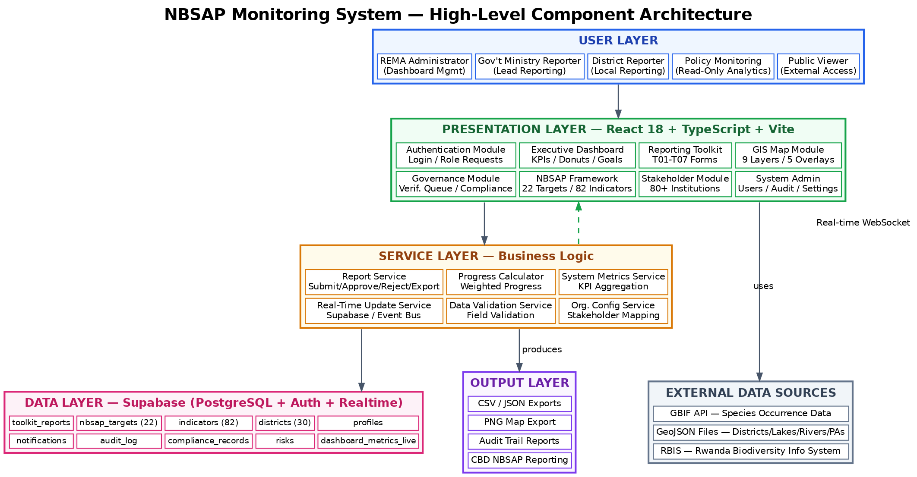
┌─────────────────────────────────────────────────────────────────────┐
│ END USERS │
│ ┌───────────┐ ┌───────────┐ ┌───────────┐ ┌───────────┐ │
│ │ REMA │ │ Ministry │ │ District │ │ Policy │ │
│ │ Admins │ │ Reporters │ │ Officers │ │ Monitors │ │
│ └─────┬─────┘ └─────┬─────┘ └─────┬─────┘ └─────┬─────┘ │
│ │ │ │ │ │
│ ┌─────┴──────────────┴──────────────┴──────────────┴─────┐ │
│ │ Web Browser (HTTPS) │ │
│ └────────────────────────┬───────────────────────────────┘ │
└───────────────────────────┼─────────────────────────────────────────┘
│
┌───────────────────────────┼─────────────────────────────────────────┐
│ PRESENTATION LAYER │
│ React 18 SPA + TypeScript + Vite │
│ ┌──────────┐ ┌──────────┐ ┌──────────┐ ┌──────────┐ ┌──────────┐ │
│ │Dashboard │ │Reporting │ │Verific. │ │ Map │ │ RBIS │ │
│ │ Page │ │ Toolkit │ │ Queue │ │ Page │ │Dashboard │ │
│ └──────────┘ └──────────┘ └──────────┘ └──────────┘ └──────────┘ │
│ ┌──────────┐ ┌──────────┐ ┌──────────┐ ┌──────────┐ ┌──────────┐ │
│ │ Targets │ │Indicators│ │ Reports │ │Compliance│ │ User │ │
│ │ Page │ │ Page │ │& Analyt. │ │& Risk │ │ Mgmt │ │
│ └──────────┘ └──────────┘ └──────────┘ └──────────┘ └──────────┘ │
│ (16 pages, 50+ components, lazy-loaded) │
├────────────────────────────┬────────────────────────────────────────┤
│ APPLICATION LAYER │
│ ┌──────────────┐ ┌──────────────┐ ┌──────────────┐ │
│ │ 10+ Custom │ │ 8 Service │ │ Event Bus │ │
│ │ React Hooks │ │ Modules │ │ (Real-time) │ │
│ └──────────────┘ └──────────────┘ └──────────────┘ │
│ ┌──────────────┐ ┌──────────────┐ ┌──────────────┐ │
│ │ Validation │ │ Error │ │ Progress │ │
│ │ Engine │ │ Handling │ │ Calculator │ │
│ └──────────────┘ └──────────────┘ └──────────────┘ │
├────────────────────────────┬────────────────────────────────────────┤
│ INTEGRATION LAYER │
│ ┌──────────────┐ ┌──────────────┐ ┌──────────────┐ │
│ │ Supabase │ │ GBIF Proxy │ │ RBIS API │ │
│ │ JS Client │ │ Edge Func. │ │ Client │ │
│ └──────┬───────┘ └──────┬───────┘ └──────┬───────┘ │
├─────────┼────────────────┼────────────────┼────────────────────────┤
│ │ DATA LAYER │ │
│ ┌──────▼────────────────▼────────┐ ┌────▼───────────┐ │
│ │ PostgreSQL 15 Database │ │ External APIs │ │
│ │ 18 Tables │ 7 Triggers │ │ GBIF, RBIS │ │
│ │ 25+ RLS │ 10+ Functions │ │ GeoJSON files │ │
│ │ 20+ Index │ 22 Migrations │ └────────────────┘ │
│ └────────────────────────────────┘ │
│ ┌────────────────┐ ┌────────────────┐ ┌────────────────┐ │
│ │ Supabase Auth │ │ Supabase │ │ Supabase │ │
│ │ (JWT/Sessions) │ │ Storage (S3) │ │ Realtime (WS) │ │
│ └────────────────┘ └────────────────┘ └────────────────┘ │
└────────────────────────────────────────────────────────────────────┘

SECTION 3: BUSINESS PROCESS DOCUMENT

3.1 Current Process (AS-IS)

3.1.1 Pre-System Data Collection Process
Before the NBSAP Monitoring Dashboard, biodiversity data collection in Rwanda followed a manual, fragmented process:
District Field Officer
│
├── Collects biodiversity data manually (paper forms, notebooks)
│
├── Compiles data into Excel spreadsheets
│
├── Emails spreadsheet to Ministry focal point
│
▼
Ministry Focal Point
│
├── Receives spreadsheets from multiple districts
│
├── Manually aggregates data in master spreadsheet
│
├── Performs calculations (totals, averages, percentages)
│
├── Drafts narrative report in Word/PDF
│
├── Emails compiled report to REMA
│
▼
REMA M&E Officer
│
├── Receives reports from multiple ministries
│
├── Cross-checks data against previous submissions
│
├── Requests corrections via email (often multiple rounds)
│
├── Manually compiles national-level summary
│
├── Prepares CBD National Report sections
│
▼
National Reporting
├── PDF reports distributed to stakeholders
└── Manual compilation for CBD Secretariat

3.1.2 AS-IS Process Challenges and Bottlenecks
Challenge | Impact | Severity
No standard data format | Each ministry uses different spreadsheet structures; data aggregation is error-prone | High
Email-based review | Submissions lost, delayed, or duplicated; no tracking of review status | High
No verification workflow | Data published without formal quality assurance; errors propagate to national metrics | Critical
Manual calculations | Human computation errors in aggregating hectares, budgets, incident counts | High
No audit trail | Cannot determine who submitted, modified, or approved specific data points | Critical
Delayed visibility | National progress only visible quarterly (at best); no real-time monitoring | Medium
No geographic analysis | No spatial capability to visualise district-level patterns or biodiversity hotspots | Medium
Role confusion | No formal access control; anyone with email access can view or modify reports | High
Version control issues | Multiple versions of spreadsheets circulating; no single source of truth | High
CBD reporting burden | Weeks of manual compilation to prepare periodic National Reports | High

3.1.3 AS-IS Process Flow Diagram
┌─────────────┐ Email ┌─────────────┐ Email ┌─────────────┐
│ District │────(Excel)──▶│ Ministry │───(Word)───▶│ REMA │
│ Officer │ │ Focal Point │ │ M&E Team │
└─────────────┘ └──────┬──────┘ └──────┬──────┘
│ │
Email corrections Email corrections (multiple rounds) (multiple rounds)
│ │
▼ ▼
┌─────────────┐ ┌─────────────┐
│ Revised │ │ National │
│ Spreadsheet│ │ Summary │
└─────────────┘ │ (Manual) │
└──────┬──────┘
│
▼
┌─────────────┐
│ CBD Report │
│ (PDF) │
└─────────────┘
Problems: No tracking ──── No verification ──── No audit ──── Weeks of delay

3.2 Proposed Process (TO-BE)

3.2.1 Automated Digital Process
Institution Reporter / District Officer
│
├── Logs into NBSAP Dashboard (email + password, JWT auth)
│
├── Selects Reporting Tool (T01–T07)
│
├── Completes structured form with validated fields
│
├── Attaches evidence documents (uploaded to Supabase Storage)
│
├── Selects NBSAP target alignment and district
│
├── System validates all inputs (type, range, required fields)
│
├── Submits report → Status: PENDING
│
├── Audit log entry created automatically
│
├── Notification sent to authorised reviewers
│
▼
Sector Reviewer / REMA M&E Officer
│
├── Opens Verification Queue
│
├── Reviews submission: form data + evidence attachments
│
├── DECISION:
│ │
│ ├── APPROVE
│ │ ├── Status → APPROVED
│ │ ├── Database trigger fires → metrics auto-update
│ │ ├── Target progress recalculated (weighted)
│ │ ├── WebSocket pushes update to all dashboards
│ │ ├── Notification sent to reporter: "Approved"
│ │ └── Audit log entry created
│ │
│ └── REJECT
│ ├── Reviewer enters rejection reason (mandatory)
│ ├── Status → REJECTED
│ ├── Notification sent to reporter with reason
│ ├── Reporter may revise and resubmit
│ └── Audit log entry created
│
▼
Dashboard Publication (Automatic)
│
├── All connected browsers receive real-time WebSocket update
│
├── Dashboard metrics refresh automatically
│
├── Target progress bars update immediately
│
├── District compliance scores recalculated
│
└── Data available for export (CSV, PDF, JSON)

3.2.2 Detailed Workflow Diagrams
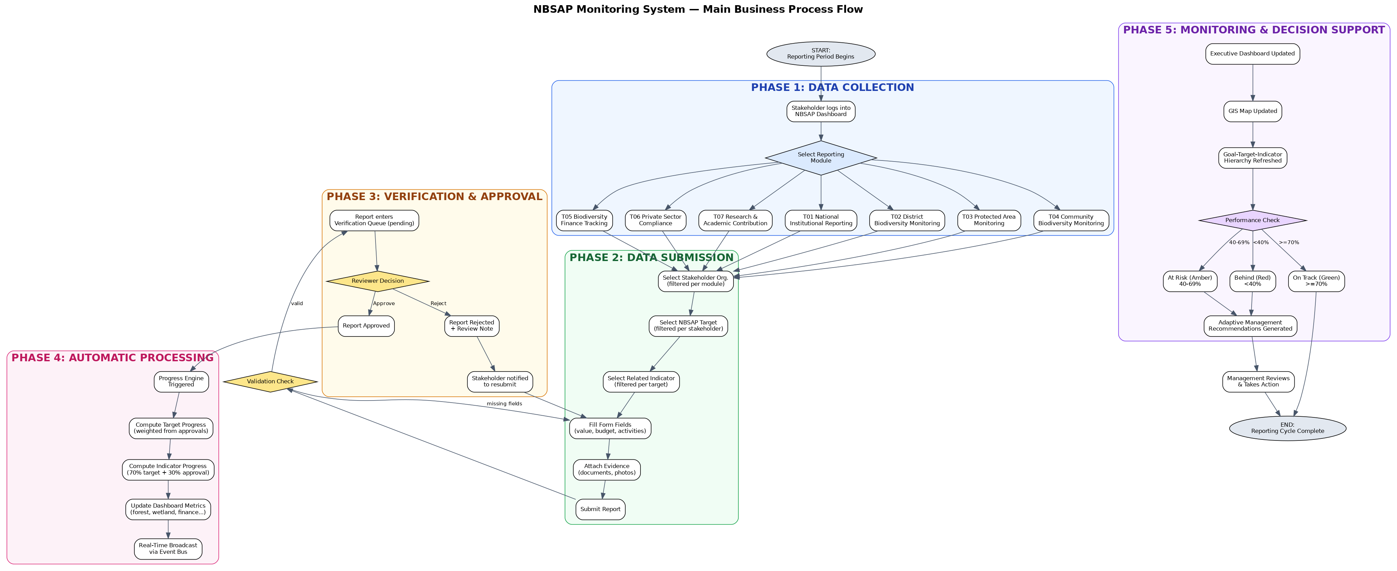
Submission Workflow
START
│
├─ Reporter authenticates (JWT session)
│
├─ System checks: role has canSubmitReports permission?
│ ├── NO → Access denied page
│ └── YES → Continue
│
├─ Reporter selects tool (T01–T07)
│
├─ System renders tool-specific form fields
│ ├── T01: institution, budget_utilised, compliance_score, policy_progress
│ ├── T02: district, forest_hectares, wetland_hectares, land_cover_change
│ ├── T03: area_name, coverage_km2, mgmt_effectiveness, illegal_cases
│ ├── T04: incident_type, district, species, hwc_case_count, mitigation
│ ├── T05: budget_allocated, budget_disbursed, finance_source
│ ├── T06: company, eia_status, sector, restoration_commitments
│ └── T07: community_name, district, participant_count, traditional_knowledge
│
├─ Reporter fills form fields
│
├─ Reporter selects reporting period (year validated: 2020–2030)
│
├─ Reporter selects NBSAP target alignment
│
├─ Reporter uploads evidence (optional attachments)
│
├─ Reporter clicks SUBMIT
│
├─ CLIENT-SIDE VALIDATION:
│ ├── Required fields present?
│ ├── Numeric values within valid ranges?
│ ├── Year within 2020–2030?
│ ├── PASS → proceed
│ └── FAIL → display validation errors; block submission
│
├─ Supabase API call: INSERT into toolkit_reports
│ ├── RLS policy check (can_write() function)
│ ├── Database constraints check (NOT NULL, CHECK, FK)
│ ├── form_data stored as JSONB
│ └── status = 'pending'
│
├─ Attachments uploaded to Supabase Storage
│
├─ Audit log entry: action_type='submit'
│
├─ Notification created for reviewers
│
END → Report visible in Verification Queue
Review Workflow
START
│
├─ Reviewer opens Verification Queue
│
├─ System checks: role has canApproveReports permission?
│ ├── NO → Page not accessible
│ └── YES → Queue displayed
│
├─ Queue shows all pending submissions:
│ ├── Submitter name and role
│ ├── Tool type (T01–T07) with icon
│ ├── District and institution
│ ├── Submission date
│ └── Status badge (Pending/Approved/Rejected)
│
├─ Reviewer selects a submission
│
├─ System displays:
│ ├── Full form_data fields and values
│ ├── Evidence attachments (downloadable)
│ ├── Reporter profile and organisation
│ └── Historical submissions for same district/tool
│
├─ REVIEWER DECISION:
│ │
│ ├── APPROVE → UPDATE status='approved', reviewed_by, reviewed_at
│ │ └── Triggers fire (see Approval Workflow below)
│ │
│ ├── REJECT → Reviewer enters rejection reason
│ │ ├── UPDATE status='rejected', review_note, reviewed_by, reviewed_at
│ │ ├── Notification to reporter with rejection reason
│ │ └── Reporter can revise and resubmit (new submission)
│ │
│ └── RESET TO PENDING → UPDATE status='pending' (undo previous decision)
│
END
Approval Workflow (Automated Post-Approval)
Report status changes to 'approved'
│
├─ Database trigger: on_report_approved fires
│
├─ Trigger extracts metric values from form_data JSONB:
│ ├── T02 → forest_hectares, wetland_hectares
│ ├── T03 → coverage_km2, mgmt_effectiveness, illegal_cases
│ ├── T04 → hwc_case_count
│ ├── T05 → budget_allocated, budget_disbursed
│ ├── T06 → eia_status (full/partial/non), restoration_ha
│ └── T07 → participant_count, traditional_knowledge_count
│
├─ system_metrics table updated (INSERT or UPDATE)
│
├─ Weighted progress trigger fires:
│ ├── Lookup tool_weights for this tool and target
│ ├── Calculate: target_progress = SUM(tool_weight × tool_metric)
│ └── UPDATE nbsap_targets.progress
│
├─ Supabase Realtime broadcasts change via WebSocket
│
├─ All connected browsers receive update
│ ├── Dashboard metrics refresh
│ ├── Target progress bars update
│ └── District compliance recalculated
│
├─ Notification created: "Your report was approved"
│
└── Audit log entry: action_type='approve'
Escalation Workflow
Submission remains PENDING for > 48 hours
│
├─ (Future enhancement) System generates overdue alert
│
├─ REMA Administrator monitors queue aging
│
├─ Admin contacts designated reviewer
│
└── If reviewer unavailable:
├── Admin assigns alternate reviewer
└── Admin may approve directly (dashboard_management role)

3.3 Approval Flow

3.3.1 Complete Approval Flow Diagram
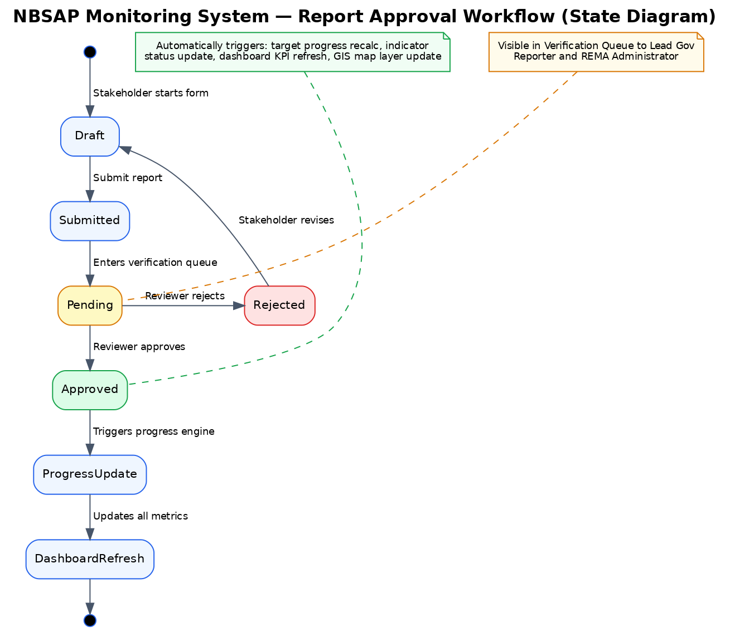
┌────────────┐
│ SUBMISSION │ Reporter submits via T01–T07
└─────┬──────┘
│
▼
┌────────────┐
│ VALIDATION │ Client-side + database constraint checks
└─────┬──────┘
│
├── FAIL → Validation errors displayed; submission blocked
│
▼ PASS
┌────────────┐
│ PENDING │ Report stored in database; enters Verification Queue
└─────┬──────┘
│
├── Notification sent to authorised reviewers
│
▼
┌────────────┐
│ REVIEW │ Reviewer examines form data + evidence
└─────┬──────┘
│
├─── APPROVE ──────────────────────────┐
│ │
├─── REJECT ───────────┐ │
│ │ │
▼ ▼ ▼
┌────────────┐ ┌────────────┐ ┌────────────┐
│ REJECTED │ │RESUBMISSION│ │ APPROVED │
│ │ │ Reporter │ │ │
│ Reason │ │ revises │ │ Triggers │
│ recorded │ │ data │ │ fire │
└────────────┘ └─────┬──────┘ └─────┬──────┘
│ │
▼ ▼
┌────────────┐ ┌────────────┐
│ PENDING │ │PUBLICATION │
│ (new sub) │ │ Metrics │
└────────────┘ │ updated │
│ Dashboard │
│ refreshed │
└────────────┘

SECTION 4: SOFTWARE REQUIREMENTS SPECIFICATION (SRS)

4.1 Functional Requirements

4.1.1 User Management
Req  ID | Description | Inputs | Processing | Outputs | Priority
FR-  UM-  001 | User  Registration | Email, password | Supabase Auth creates account; trigger creates profiles row with default role (policy_monitoring) | User account created; confirmation | Must  Have
FR-  UM-  002 | User  Authentication | Email, password | Supabase Auth validates credentials; issues JWT access + refresh tokens | Authenticated session; redirect to dashboard | Must  Have
FR-  UM-  003 | Password Reset | Email | Supabase Auth sends password reset email | Reset link sent to user's email | Must  Have
FR-  UM-  004 | Session  Management | JWT tokens | Access token auto-refreshes via refresh token; no relogin during active use | Continuous authenticated session | Must  Have
FR-  UM-  005 | Role  Assignment | User ID, new role | Admin updates profiles.role; RLS policies enforce new access level immediately | User access level changed | Must  Have
FR-  UM-  006 | Account  Suspension | User ID, reason, optional end date | Admin sets suspended_at, suspension_reason, suspension_end_date | Account locked; user cannot login | Must  Have
FR-  UM-  007 | Auto-  Reactivation | Suspension end date | System checks suspension_end_date on login; if expired, clears  suspension | Account automatically unlocked | Should  Have
FR-  UM-  008 | Account  Deactivation | User ID | Admin sets is_active=false | Account permanently locked | Must  Have
FR-  UM-  009 | Role Change  Request | Current role, desired role, justification | User submits request; enters pending queue for admin review | Role change request created | Should  Have
FR-  UM-  010 | Role Change  Approval | Request ID, decision, note | Admin approves/rejects; if approved, user role updated via trigger | User role updated or rejection sent | Should  Have
FR-  UM-  011 | User Profile  Update | Full name, organisation, department, phone | User updates own profile fields (RLS: own record only) | Profile updated | Must  Have
FR-  UM-  012 | User Listing | Filters (role, status, search) | Admin queries all profiles with pagination | User list with metadata | Must  Have

4.1.2 Dashboard Management
Req  ID | Description | Inputs | Processing | Outputs | Priority
FR-  DM-  001 | Dashboard  Generation | None (auto) | System queries system_metrics, nbsap_targets, recent reports | Executive dashboard rendered | Must  Have
FR-  DM-  002 | 13 Automated Metrics Display | None (auto) | Fetch from system_metrics table (trigger-computed) | Metric cards with values, labels,  units | Must  Have
FR-  DM-  003 | Target Progress  Tracking | None (auto) | Fetch all 22 targets with computed progress | Progress bars with 3-colour coding | Must  Have
FR-  DM-  004 | Red Flag  Monitoring | Progress thresholds | Targets with progress < 40% flagged red; indicators marked "behind" | Visual red status badges | Must  Have
FR-  DM-  005 | Real-Time  Update | WebSocket event | Supabase Realtime pushes changes; React state updates | Dashboard refreshes without page reload | Should  Have
FR-  DM-  006 | District  Compliance  Map | District data | Fetch districts with compliance scores; render on Leaflet map | Colour-coded district map | Must  Have
FR-  DM-  007 | Recent Reports  Display | Approved reports | Fetch last 4 approved toolkit_reports with submitter info | Recent activity cards | Should  Have

4.1.3 Reporting
Req  ID | Description | Inputs | Processing | Outputs | Priority
FRRP001 | T01  Submission | Institution, budget, compliance, policy progress | Validate fields; INSERT toolkit_reports with tool_id='T01' | Report stored with status='pending' | Must  Have
FRRP002 | T02  Submission | District, forest ha, wetland ha, land cover | Validate fields; INSERT with tool_id='T02' | Report stored with status='pending' | Must  Have
FRRP003 | T03  Submission | Area name, coverage, effectiveness, illegal cases | Validate fields; INSERT with tool_id='T03' | Report stored with status='pending' | Must  Have
FRRP004 | T04  Submission | Incident type, district, species, HWC count | Validate fields; INSERT with tool_id='T04' | Report stored with status='pending' | Must  Have
FRRP005 | T05  Submission | Budget allocated, disbursed, source | Validate fields; INSERT with tool_id='T05' | Report stored with status='pending' | Must  Have
FRRP006 | T06  Submission | Company, EIA status, sector, restoration | Validate fields; INSERT with tool_id='T06' | Report stored with status='pending' | Must  Have
FRRP007 | T07  Submission | Community, district, participants, TK | Validate fields; INSERT with tool_id='T07' | Report stored with status='pending' | Must  Have
FRRP008 | Evidence  Upload | File  (document/image) | Upload to Supabase  Storage; link to report | Attachment stored and linked | Must  Have
FRRP009 | Report  Approval | Report ID, reviewer decision | UPDATE  status='approved'; trigger fires metric update | Metrics updated; notification sent | Must  Have
FRRP010 | Report  Rejection | Report ID, rejection reason | UPDATE  status='rejected'; notification with reason | Reporter notified with feedback | Must  Have
FRRP011 | Report  Export (CSV) | Filters (tool, date, district) | Query filtered reports; generate CSV | CSV file  downloaded | Must  Have
FRRP012 | Report  Export (PDF) | Filters | Query filtered reports; generate formatted  PDF | PDF file  downloaded | Must  Have
FRRP013 | Report  Export  (JSON) | Filters | Query filtered reports; serialise to JSON | JSON file downloaded | Should  Have
FRRP014 | Report  Deletion | Report ID | DELETE from  toolkit_reports; if was approved, trigger reverses metrics | Report removed; metrics reversed | Must  Have

4.1.4 Audit and Compliance
Req  ID | Description | Inputs | Processing | Outputs | Priority
FRAC-  001 | Audit Logging | Action type, action, detail, user ID | INSERT into audit_log  (append-only, immutable) | Audit entry created | Must  Have
FRAC-  002 | Audit Log  Viewing | Filters (user, action_type, date  range) | Admin queries audit_log with filters | Filtered audit trail displayed | Must  Have
FRAC-  003 | Change  Tracking | Before/after values | Audit entry includes detail field with change context | Change history queryable | Must  Have
FRAC-  004 | User Activity  Monitoring | User ID | Query audit_log by user_id | User's activity history | Must  Have
FR-  AC- | Risk Register | Risk data  (description, | CRUD operations on risks table | Risk register maintained | Should  Have
005 |  | category, level)
FRAC-  006 | Compliance  Records | Compliance data | CRUD operations on compliance_records | Compliance tracking maintained | Should  Have

4.2 Non-Functional Requirements

4.2.1 Performance
Req ID | Requirement | Target | Measurement Method
NFR-P-  001 | Initial page load time | < 3 seconds on 4G connection | Browser DevTools /  Lighthouse
NFR-P-  002 | Dashboard metrics display | < 2 seconds | Supabase query latency
NFR-P-  003 | API response time (p50) | < 200ms | Supabase dashboard metrics
NFR-P-  004 | API response time (p95) | < 500ms | Supabase dashboard metrics
NFR-P-  005 | Map render time | < 2 seconds | Chrome Performance tab
NFR-P-  006 | Concurrent user capacity | 500 users | Load testing
NFR-P-  007 | Report storage capacity | 10,000+ reports | Database capacity planning
NFR-P-  008 | Search response time | < 500ms | Client-side measurement
NFR-P-  009 | Code splitting | Every page lazy-loaded | Bundle analysis
NFR-P-  010 | Asset caching | 1-year cache headers on hashed assets | Response header inspection

4.2.2 Security
Req ID | Requirement | Implementation
NFR-S-001 | HTTPS/TLS encryption | All traffic encrypted via TLS 1.2+ (Vercel + Supabase)
NFR-S-002 | JWT authentication | Supabase Auth issues JWT access + refresh tokens
NFR-S-003 | Password hashing | bcrypt via Supabase Auth
NFR-S-004 | Row-Level Security | 25+ PostgreSQL RLS policies on all 18 tables
NFR-S-005 | Content Security Policy | CSP headers restrict script/style sources
NFR-S-006 | Clickjacking protection | X-Frame-Options: DENY
NFR-S-007 | MIME sniffing prevention | X-Content-Type-Options: nosniff
NFR-S-008 | XSS protection | X-XSS-Protection: 1; mode=block
NFR-S-009 | Immutable audit log | Append-only audit_log table; no UPDATE/DELETE allowed
NFR-S-010 | Input validation | Client-side TypeScript + database constraints
NFR-S-011 | File upload security | Supabase Storage with bucket-level access policies
NFR-S-012 | Session management | JWT auto-refresh; stale session detection

4.2.3 Availability
Req ID | Requirement | Target
NFR-A-001 | System uptime | 99.5% annually
NFR-A-002 | Database backup frequency | Daily (automated by Supabase)
NFR-A-003 | Recovery Point Objective (RPO) | 24 hours
NFR-A-004 | Recovery Time Objective (RTO) | 4 hours
NFR-A-005 | Zero-downtime deployment | Vercel auto-deploy with instant rollback
NFR-A-006 | Graceful degradation | System functional without GBIF/RBIS (external APIs)

4.2.4 Scalability
Req ID | Requirement | Implementation
NFR-SC-001 | Horizontal scaling | Serverless architecture (Vercel + Supabase) auto-scales
NFR-SC-002 | CDN distribution | Vercel serves static assets from 200+ global edge locations
NFR-SC-003 | Database scaling | Supabase Pro tier: 8GB database, connection pooling (PgBouncer)
NFR-SC-004 | Additional institutions | New organisations added via user management; no code changes
NFR-SC-005 | Additional indicators | Indicators table supports unlimited rows; UI paginated
NFR-SC-006 | Storage scaling | Supabase Pro tier: 100GB file storage

4.2.5 Usability
Req ID | Requirement | Implementation
NFR-U-  001 | WCAG 2.1 AA compliance | Colour contrast 4.5:1 minimum; ARIA labels on all interactive elements
NFR-U-  002 | Keyboard navigation | Full Tab/Enter/Space/Escape keyboard support
NFR-U-  003 | Screen reader support | Semantic HTML; aria-live regions for real-time updates
NFR-U-  004 | Responsive design | Adaptive layout: desktop (>1024px), tablet (768–1024px), mobile  (<768px)
NFR-U-  005 | Consistent visual language | 3-colour progress system (green/amber/red) used consistently
NFR-U-  006 | Loading states | Skeleton screens during data fetch; loading spinners for actions
NFR-U-  007 | Error messages | User-friendly error messages with actionable guidance
NFR-U-  008 | Browser compatibility | Chrome 90+, Firefox 88+, Safari 14+, Edge 90+

SECTION 5: USER ROLES AND PERMISSIONS

5.1 Role Definitions

5.1.1 Administrator — dashboard_management
Attribute | Value
Label | REMA Administrator
Typical  Users | REMA national team, system administrators
Description | Full system access: verification queue, user management, audit log, all exports
User Count | 2–5
Permissions | ALL (canSubmitReports, canApproveReports, canViewVerifQueue, canViewAuditLog, canManageUsers, canExportRaw, canViewRiskRegister, canViewCompliance, canViewAnalytics)

5.1.2 REMA M&E Officer / Lead Ministry Reporter —
lead_government_ministry_reporting
Attribute | Value
Label | Lead Government Ministry Reporter
Typical  Users | Ministry focal points, sector ministry officers
User Count | 10–20
Permissions | canSubmitReports, canApproveReports, canViewVerifQueue, canExportRaw, canViewRiskRegister, canViewCompliance, canViewAnalytics

5.1.3 Sector Reviewer / District Officer — local_reporting
Attribute | Value
Label | Local Reporter
Typical Users | District environmental officers (30 districts)
User Count | 30–60
Permissions | canSubmitReports, canViewCompliance

5.1.4 Institution Reporter / Policy Monitor — policy_monitoring
Attribute | Value
Label | Policy Monitor
Typical Users | National policymakers, Cabinet-level advisors, MoE oversight
User Count | 5–15
Permissions | canViewRiskRegister, canViewCompliance, canViewAnalytics (READ-ONLY)

5.1.5 Viewer / Development Partner — programme_alignment
Attribute | Value
Label | Development Partner
Typical Users | NGOs, research institutions, donors
User Count | 10–30
Permissions | canViewRiskRegister, canViewCompliance, canViewAnalytics (READ-ONLY)

5.1.6 Auditor / Public Viewer — public_viewer
Attribute | Value
Label | Public Viewer
Typical Users | General public, media, academic researchers
User Count | Unlimited
Permissions | View dashboard, targets, indicators, map ONLY (no other permissions)

5.2 Detailed Permission Matrix
Permission | REMA  Admin | Ministry  Reporter | District  Officer | Policy  Monitor | Dev  Partner | Public  Viewer
canSubmitReports | YES | YES | YES | NO | NO | NO
canApproveReports | YES | YES | NO | NO | NO | NO
canViewVerifQueue | YES | YES | NO | NO | NO | NO
canViewAuditLog | YES | NO | NO | NO | NO | NO
canManageUsers | YES | NO | NO | NO | NO | NO
canExportRaw | YES | YES | NO | NO | NO | NO
canViewRiskRegister | YES | YES | NO | YES | YES | NO
canViewCompliance | YES | YES | YES | YES | YES | NO
canViewAnalytics | YES | YES | NO | YES | YES | NO
View Dashboard | YES | YES | YES | YES | YES | YES
View Targets | YES | YES | YES | YES | YES | YES
View Indicators | YES | YES | YES | YES | YES | YES
View Map | YES | YES | YES | YES | YES | YES
View RBIS | YES | YES | YES | YES | YES | YES
User Management | YES | NO | NO | NO | NO | NO
Role Requests | YES | NO | NO | NO | NO | NO
Data Pipeline | YES | NO | NO | NO | NO | NO
Stakeholders | YES | NO | NO | NO | NO | NO
Settings (own) | YES | YES | YES | YES | YES | YES

ErrorBoundary (top-level)
│
├── Catches unhandled JavaScript errors in component tree
│
├── Displays fallback UI with:
│ ├── Error description
│ ├── "Try Again" button (re-renders component)
│ └── "Return to Dashboard" link
│
└── RBISErrorBoundary (RBIS-specific)
├── Catches RBIS dashboard errors independently
└── Allows rest of application to continue functioning

SECTION 6: APPENDICES

Appendix A: Glossary
Term | Definition
NBSAP | National Biodiversity Strategy and Action Plan
KM-GBF | Kunming-Montreal Global Biodiversity Framework
CBD | Convention on Biological Diversity
REMA | Rwanda Environment Management Authority
GBIF | Global Biodiversity Information Facility
RBIS | Rwanda Biodiversity Information System
RLS | Row-Level Security (PostgreSQL feature)
JWT | JSON Web Token
BaaS | Backend-as-a-Service
SPA | Single-Page Application
CDN | Content Delivery Network
GIS | Geographic Information System
EIA | Environmental Impact Assessment
HWC | Human-Wildlife Conflict
ABS | Access and Benefit Sharing
IAS | Invasive Alien Species
NbS | Nature-based Solutions
TRSP | Tourism Revenue Sharing Program
PA | Protected Area
OECM | Other Effective area-based Conservation Measure

Appendix B: Acronyms — Government Institutions
Acronym | Full Name
REMA | Rwanda Environment Management Authority
MoE | Ministry of Environment
MINECOFIN | Ministry of Finance and Economic Planning
MINAGRI | Ministry of Agriculture and Animal Resources
MININFRA | Ministry of Infrastructure
MINICOM | Ministry of Trade and Industry
MINEDUC | Ministry of Education
RDB | Rwanda Development Board
RFA | Rwanda Forestry Authority
RAB | Rwanda Agriculture and Animal Resources Development Board
RNRA | Rwanda Natural Resources Authority
WASAC | Water and Sanitation Corporation
BNR | National Bank of Rwanda
PSF | Private Sector Federation
RBS | Rwanda Bureau of Standards
NISR | National Institute of Statistics of Rwanda

Appendix C: Assumptions
# | Assumption | Rationale
1 | District officers have internet access | Rwanda's broadband coverage exceeds 95% of urban areas
2 | REMA will designate at least 2 system administrators | Ongoing system management requires institutional commitment
3 | GBIF API remains publicly accessible | GBIF is multilateral infrastructure with long-term funding
4 | Supabase maintains service availability | Supabase provides 99.9% uptime SLA
5 | Ministry reporters are trained on the 7 reporting tools | Training is part of system deployment
6 | Data collection follows quarterly/annual reporting cycles | Aligned with Rwanda's existing M&E calendar
7 | Evidence documents are available in digital format | Increasing digitisation of field operations

Appendix D: Dependencies
Dependency | Type | Risk
Supabase Cloud | Infrastructure | Medium — single provider for database, auth, storage
Vercel CDN | Infrastructure | Low — easy to migrate to Netlify or self-host
GBIF API | External data | Low — system functions without GBIF data
RBIS API | External data | Low — system functions without RBIS data
React ecosystem | Technology | Low — LTS; large community; stable
PostgreSQL | Technology | Very Low — industry standard; managed by Supabase
Modern browsers | Client | Low — Rwanda's browser adoption skews modern

Appendix E: Risks
# | Risk | Likelihood | Impact | Mitigation
1 | Supabase free tier limits exceeded | Medium | Medium | Monitor usage; upgrade to Pro tier ($25/month)
2 | Key personnel leave  REMA | Medium | High | Document all processes; train multiple administrators
3 | GBIF API becomes unavailable | Low | Low | System functions without GBIF; cached data shown
4 | Security breach attempt | Medium | High | RLS policies, HTTPS, CSP headers, audit logging,  JWT auth
5 | Data loss | Low | Critical | Daily automated Supabase backups; gitversioned migrations
6 | Internet connectivity disruption | Medium | Medium | System designed for low-bandwidth; CDN caching reduces data transfer
7 | Browser compatibility issues | Low | Low | Standard React/TypeScript; modern browser requirement documented

Appendix F: Recommendations
# | Recommendation | Priority | Rationale
1 | Upgrade Supabase to Pro tier before user base exceeds 100 | High | Ensures database, storage, and backup capacity
2 | Implement multi-language support  (Kinyarwanda, French) | Medium | Improves accessibility for district-level officers
3 | Develop mobile application (React Native) | Medium | Enables offline field data collection
4 | Automate CBD National Report generation | High | Reduces manual effort for periodic CBD reporting
5 | Add SMS notifications for overdue reports | Medium | Reaches users with limited email access
6 | Conduct quarterly security audits | High | Maintains security posture as system evolves

Prepared by: IUCN - NBSAP Dashboard Development Team
Document Reference: NBSAP-COMP-2026-001
Rwanda Environment Management Authority (REMA)
System: Rwanda NBSAP Monitoring Dashboard v1.0.0
Date: June 2026

